Instruments from Around the World

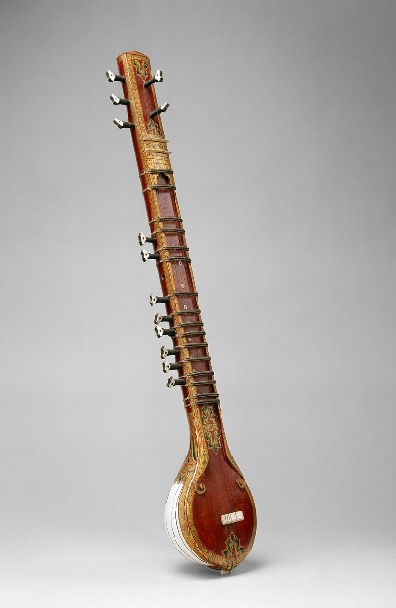
Musical instruments. They convert our actions into music, taking roles that our larynx alone cannot. They add to the joy, to the beauty, of any musical performance, infusing their own individual and distinct style into the performance. A piece can evoke a completely different emotion depending on the instrument that plays it. For instance, a violin may humanise a piece that the pipe organ made grander than life.

Sitar
Image Credits: By unknown, MET museum - https://www.metmuseum.org/art/collection/search/502150, CC0, https://commons.wikimedia.org/w/index.php?curid=124998973
Instruments have their own sense of identity, their own sense of self in a way. Here, we are embarking on a whirlwind journey through the world of music to explore the identities of some unique instruments, ranging from traditional flutes that sing the song of the Andes to a wondrous yet haunting modern electronic instrument played without any contact.
Sitar
Our first stop on this tour sits close to home. Sitar, from India, is a stringed instrument of the lute family (a family of stringed instruments whose members are defined by a pear-shaped enclosed resonator and a long neck with a fingerboard) with origins in Iran. From those 18th-century beginnings, it has evolved into a globally renowned instrument.
Sitar can have 18 to 20 strings, with six to seven of these lying over the raised curved frets on the neck, while the remaining sympathetic strings (called the tarb) run under the frets and resonate in sympathy with the main threads. The movable frets allow for finer tuning. The instrument is balanced between the player’s left foot and right knee, and plucked using a metal plectrum called the mizraab. Sitar has two bridges (a structure that supports strings in a stringed instrument): the बड़ा घोड़ा (/bada ghoda) (the larger one) for the main strings and the छोटा घोड़ा (/chhota ghoda) (the smaller one) for the sympathetic strings. The larger bridge is wider and rounded. As a string vibrates, its length changes slightly as one edge moves over the rounded bridge, promoting overtones and producing the characteristic buzzing sound called the javaari.
The instrument was first mentioned in an 18th-century text. It took on its modern shape in the late Mughal era, with the creation of the modern seven-string Sitar and the addition of sympathetic strings. By the mid-18th century, the first compositional styles dedicated to Sitar began to emerge. It reached its zenith with the maestro Vilayat Khan. Vilayat developed the elegant gayaki ang technique to mimic the melisma (singing one syllable with multiple notes) of the vocal style.
Sitar went global with the soulful Pandit Ravi Shankar in the 1950s and 1960s. Ravi went on to tour Europe and America playing Indian classical music; Sitar won hearts around the world. Fascinated by this classical instrument, George Harrison, the lead guitarist of the Beatles, undertook intensive studies with Pandit Ravi Shankar, who later went on to spark the global Raga-Rock movement.
Quena
Next up is a traditional flute from the mountains of the Andes called the quena (/kena). The name is a Hispanicised version of the original Quecha name ‘qina’. Quena has origins dating back millennia, from before the Incas dominated that mountain range. It was believed to be a connector of humanity and divinity. With time, it became the heart of celebrations and the beacon for storytelling.
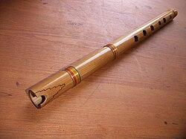
The end-blown flute is traditionally made out of cane or of wood from native Andean trees, and consists of six finger holes on the front and a thumb hole at the back. To play symphonies, the player closes the top end of the pipe with the flesh between the chin and lower lip, and blows a stream of air downward, along the axis of the pipe, over an elliptical notch called the escotadura cut into the end. The sound is produced by edge-tone generation, an acoustic phenomenon generated when a planar jet of air strikes a sharp edge or wedge, causing the airstream to rapidly oscillate back and forth. The key of G, with G4 (played with all holes closed), brings out the deepest tone. The sound has a dark, textured timbre, with a haunting, melancholic quality to it, as if it is echoing off the mountains themselves. It is no wonder this beautiful instrument became such an integral part of the Andean culture.

Quena
Image Credits: By User:Jordi Coll Costa - [1], CC BY-SA 3.0, https://commons.wikimedia.org/w/index.php?curid=5249404


Traditional didgeridoo

Ŋalkan Munuŋgurr performing [a didgeridoo] with East Journey
Image Credits: By Graham Crumb/Imagicity.com, CC BY-SA 3.0, https://commons.wikimedia.org/w/index.php?curid=25266419
Following the quena is another visually similar, though grander, instrument from Australia called the didgeridoo. However, unlike its woodwind relative from the Andes, the didgeridoo is classified by organologists (yes, there is a real science studying and classifying instruments) as a “brass” instrument. Not because it is made of brass, but because the lips and mouth of the player select its actual frequency/harmonic. This Aboriginal instrument is traditionally made from the hardwoods of the continent, especially the famed Eucalyptus. Individual trees are often chosen based on their termite activity. It can measure anywhere from a metre to three.
The basic characteristic drone of the didgeridoo can be produced by the simple vibrating sound of the lips. Its earthy, rich sound is difficult to describe in words. The drone can typically be sustained for a staggering fifty minutes. The players use the circular breathing technique for sustaining such long periods. It involves breathing in through the nose while simultaneously expelling air trapped in puffed cheeks by compressing them. This technique blazed the trail for the Aboriginal artist Mark Atkins, playing for over fifty minutes continuously!
Traditionally, the didgeridoo embarks on a solo or as a comrade to ceremonial dances, with another Aboriginal instrument, the clapstick, often providing the rhythm. The rhythm and the melody are precise, handed down over the generations. While it, or modern designs based on it, win hearts across the world, the didgeridoo remains deeply rooted in Aboriginal culture and tradition.

Xylophone
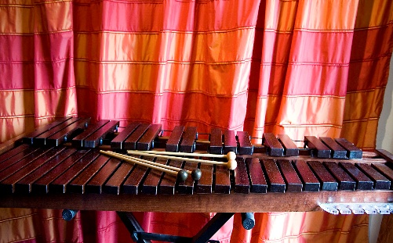
Ah, the xylophone. A percussion instrument consists of wooden (necessarily wood, otherwise it’s called a ‘glockenspiel’ if it uses metal) bars arranged in a series and struck using mallets. Surprisingly, the idea of striking bars to produce notes is neither new nor difficult to think of; multiple cultures have recorded similar forms of the instrument – for example, the gambang and rindik, which feature in the traditional gamelan music of Indonesia, and the nearly identical balafon from Africa.

Xylophone with different types of mallets
Image Credits: By Roumpf - Own work, CC BY-SA 3.0, https://commons.wikimedia.org/w/index.php?curid=14951019
Xylophone did not become a part of Western classical music until the 18th century. It was only when composers like Camille Saint-Saëns used it in Danse Macabre.
As anyone who has seen a xylophone can guess, it is pretty simple to play. The wooden bars (which act as idiophones, or instruments where the whole body vibrates) are of differing and increasing lengths, and thus, by the laws of physics bestowed upon nature, their resonant frequencies are decreasing. When struck, they produce a sound based on this frequency. Xylophones may also feature tube resonators to enhance their tone and sustain the sound, and have gourds acting as Helmholtz resonators, resembling the bafalons of Africa.
An interesting fact about them—a feature which they share with glockenspiels, their metal-barred cousins—is that their notes are typically written an octave lower than the sounding ones. This is among the many things that differentiate them from the superficially and visually similar marimba.

Pipe Organ
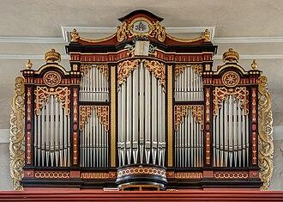
Our tour has finally brought us to the grandest instrument of all — the pipe organ.

Pipe organ in the collegiate church of St. Michael in Neunkirchen am Brand
Image Credits: By Reinhold Möller, CC BY-SA 4.0, https://commons.wikimedia.org/w/index.php?curid=105681645
You might remember it as a gigantic instrument, found in cathedrals around the globe, reaching sizes of tens of metres, and dwarfing every other instrument here. In fact, in many ways, the entire cathedral is part of the instrument, transmitting and resonating the grand sound produced. However, in reality, it can also not be that massive. The world’s smallest traditional working pipe organ measures just 12 inches high, 9 inches wide, and 5 inches deep.
The organ’s sound is produced through its pipes. Keyboards, called ‘manuals’, are used to select the pipe through which air is then forced and resonated, giving rise to the characteristic sound of the organ. Most organs have multiple manuals and a pedalboard, too, to play using feet. The large number of pipes makes it possible for a variety of different timbres. Airflow to pipes of a particular timbre can be opened and closed by the appropriately named ‘stops’, themselves controlled by the organ player using stop knobs. Pulling different stops allows the player to play the timbres of different ranks together, allowing the production of melodious harmonies. One could, of course, employ all the timbres for the grandest effect.
Organ has roots in Ancient Greece. It reached Western Europe as gifts to the Frankish kings Pepin and Charlemagne. The latter used it for his chapel at Aachen and hence started the association of the organ with the church, that solidified by the 15th century. Early organs relied on bellows pumped by humans, and because of the high wind pressure, the keys had to be held down by the force of the entire arm. Technological developments such as electric bellows and electro-pneumatic keys, among others, helped bring the grand instrument to the modern era, where it still enjoys its place among cathedrals, movie theatres and concert halls.

Theremin

And, for the final instrument in the text, we have the theremin, a strange, contactless instrument and one of my favourites. Theremin, invented by Soviet scientist Lev Theremin in the 1920s, was among the first fully electronic instruments.

Alexandra Stepanoff playing the theremin on NBC radio
Image Credits: By What's On the Air Company - What's On the Air, July 1930 (page 45), Public Domain, https://commons.wikimedia.org/w/index.php?curid=56188934
It is played by placing the hands at some distance from the two antennae. The distance from one antenna determines the frequency of the note, and the distance from the other determines the loudness. The human body effectively acts as a capacitor with the frequency antenna. By changing the position of the hand, the capacitance can be altered, which alters the resonant frequency. A signal at this variable frequency is heterodyned (combining two frequencies to produce new frequencies equal to their sum and difference) with one of a fixed frequency to create a signal with the difference of both frequencies, thus bringing out small changes in the capacitance to select notes. The volume antenna works similarly, using variable capacitance to control an amplifier that determines the amplitude and thus the loudness of the signal. The signal is fed into a loudspeaker, which converts it into a haunting and otherworldly sound.
Theremin, as I said earlier, was invented by Soviet physicist and inventor Lev Theremin, better known in the West as Leon. Fascinated by music and science at an early age, he built the first prototype of the instrument in the late 1910s or early 1920s, which he called the aetherphone in reference to the now-debunked idea of aether. He improved upon it and even played it to Lenin in 1922. It eventually landed in America in the 1928, where Leon patented the device and found a virtuoso in fellow Russian immigrant Clara Rockmore, an undeniably talented fellow. Following the Second World War, Theremin fell into disuse among serious musicians. Fortunately, a niche community survived mostly among electronics and kit-building enthusiasts, one of whom was the young Robert Moog, who later went on to invent the Moog synthesiser. The sound of the instrument, described as futuristic and ethereal, itself formed the basis of many science fiction film soundtracks. Theremin remains popular as a niche and strange instrument, producing a hauntingly beautiful sound without so much as a touch.

